1. Write a VBA code to select the cells from A5 to C10. Give it a name “Data Analytics” and fill the cells with the following cells “This is Excel VBA”

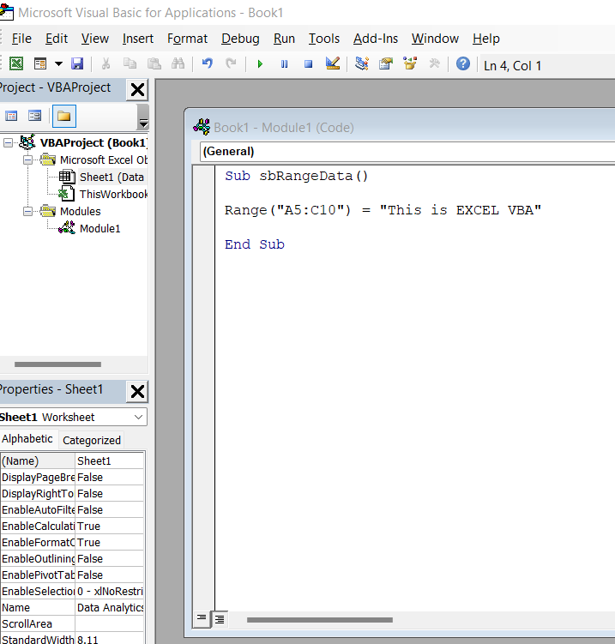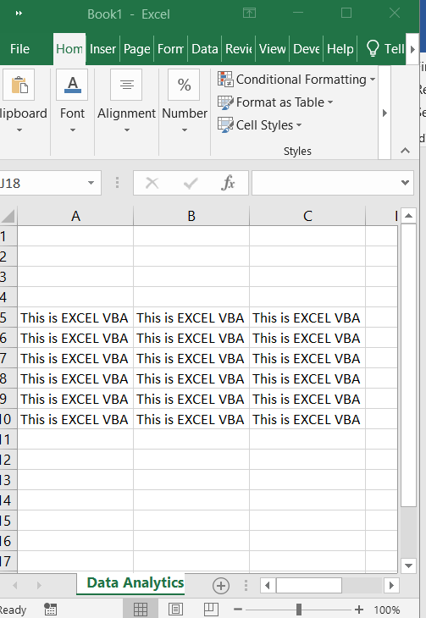

What are the types of errors that you usually see in VBA?

There are three types of errors in programming: (a) Syntax Errors, (b) Runtime Errors, and (c) Logical Errors.

How do you handle Runtime errors in VBA?

To handle an error inline, use the Resume Next statement with On Error. Any errors that occur during runtime cause InfoConnect to continue executing the macro at the next statement. If an error occurs, it is handled by opening a dialog box, passing control to another procedure or to a routine within the same procedure.

Write some good practices to be followed by VBA users for handling errors

* Use 'On Error Go [Label]' at the beginning of the code. ...
* Use 'On Error Resume Next' ONLY when you're sure about the errors that can occur. ...
* When using error handlers, make sure you're using Exit Sub before the handlers. ...
* Use multiple error handlers to trap different kinds of errors

What is UDF? Why are UDF’s used? Create a UDF to multiply 2 numbers in VBA

What is user defined function (UDF) in Excel? UDF is a custom function that takes data, performs a calculation, and returns the desired result. The source data can be numbers, text, dates, booleans, and even arrays. The result of calculations can be a value of any type that Excel works with or an array of such value

User-defined functions are functions that you use to organize your code in the body of a policy. Once you define a function, you can call it in the same way as the built-in action and parser functions. Variables that are passed to a function are passed by reference, rather than by value

